Отчёт по выполнению
Разработка, администрирование и защита баз данных

Реализация разработанной БД в MSSQL
отредактировала данные в таблицах excel, исправила дату\число, типы данных. Привела таблицы в 2-3 нормальной форме, для хранения связи многим-ко-многим создала 2 таблицы и перенесла туда данные.
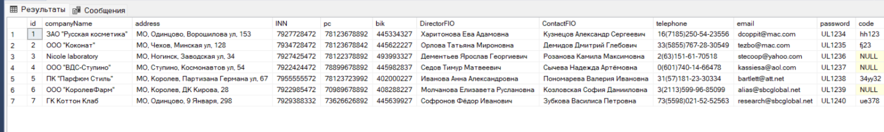

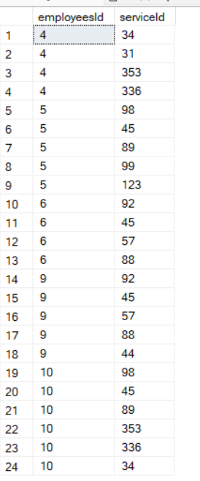
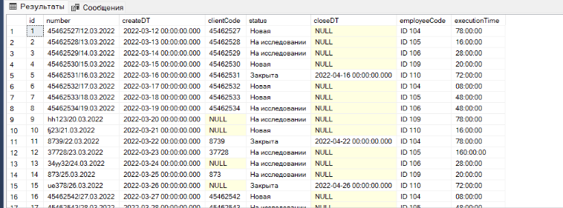

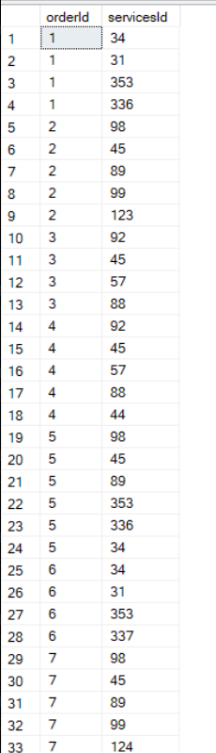
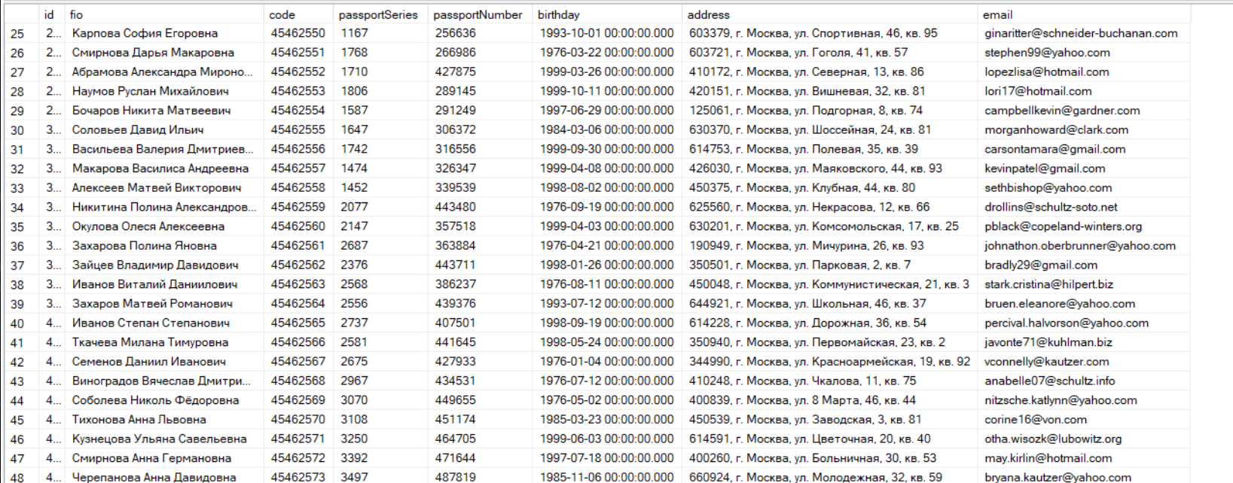

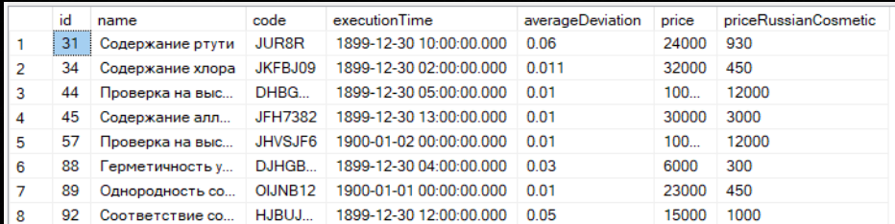

Сохранение данных и результатов
Как я поняла необходимо созданные таблицы с помощью импорта экспортировать в SQL скрипт.
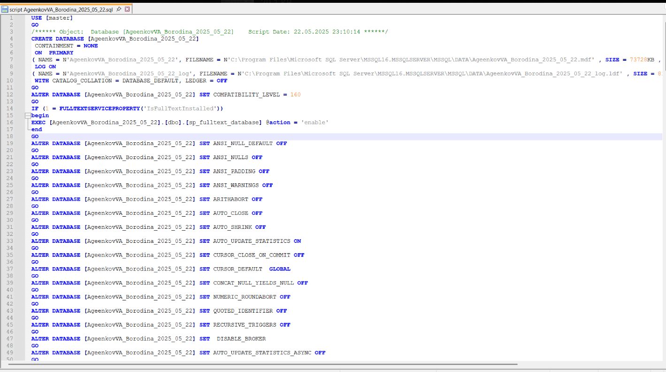

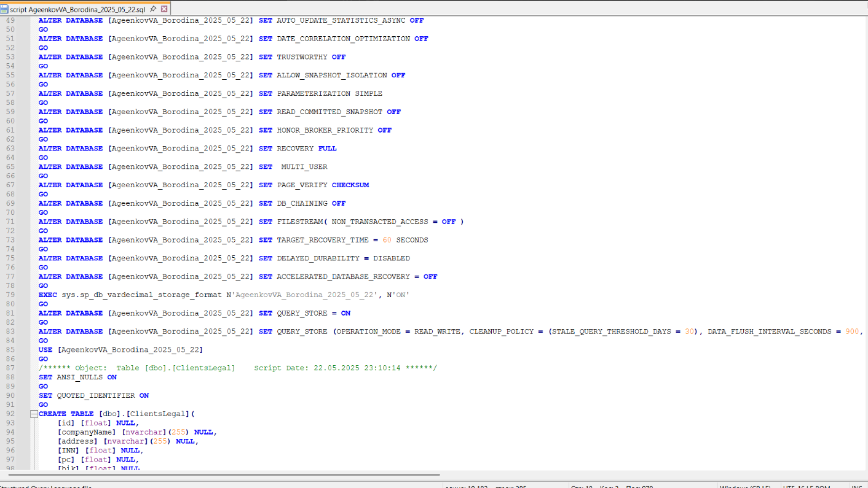

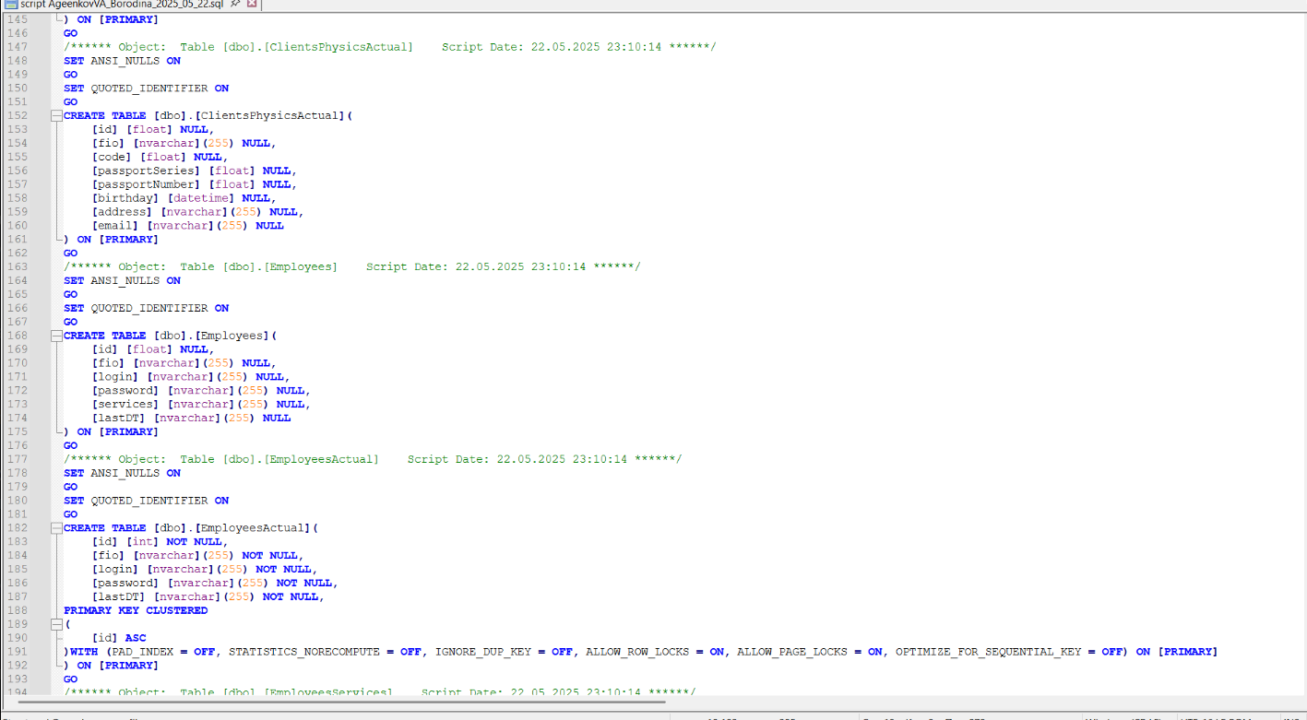

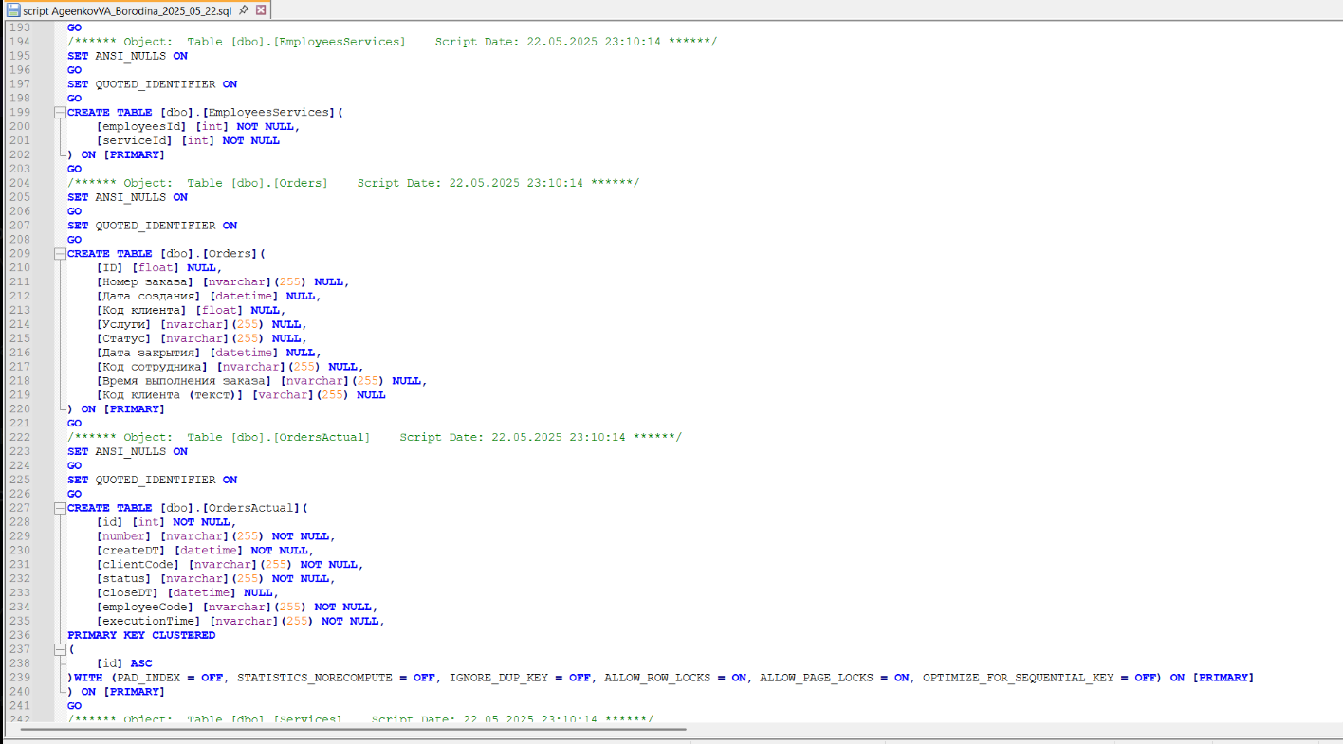

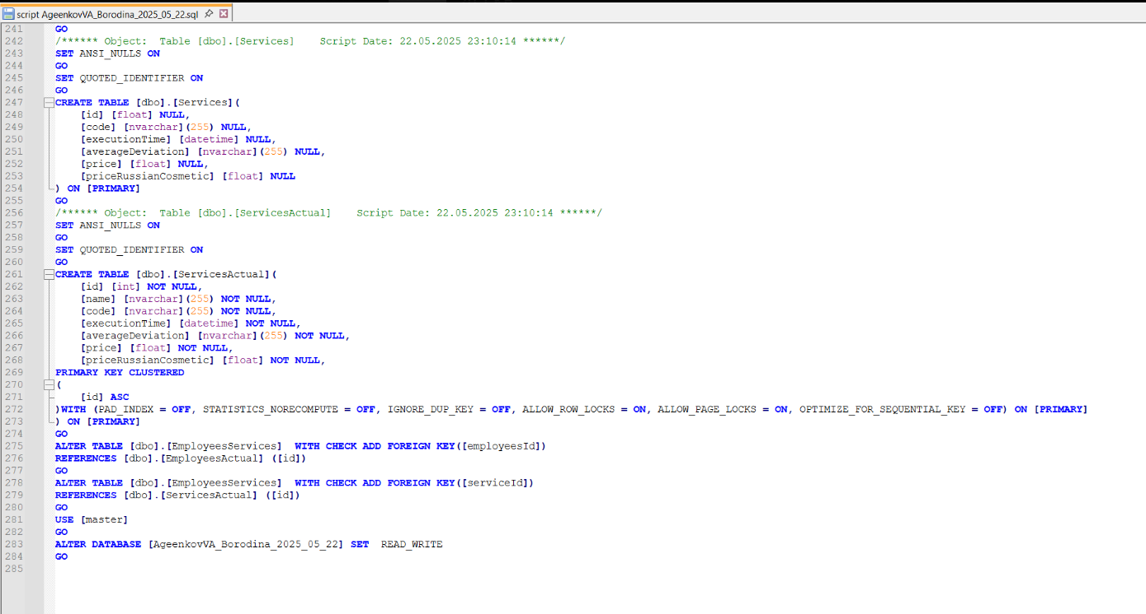

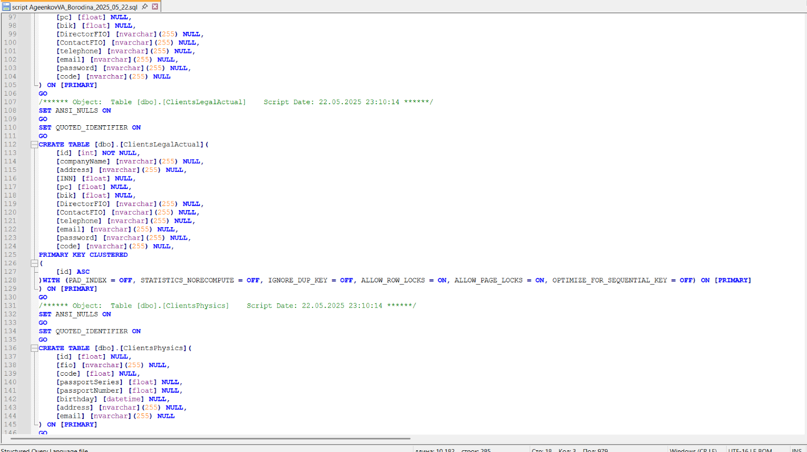

КОД (ЕСЛИ НЕУДОБНО СКРИНШОТАМИ)
USE [master]
GO
/****** Object: Database [AgeenkovVA_Borodina_2025_05_22] Script Date: 22.05.2025 23:10:14 ******/
CREATE DATABASE [AgeenkovVA_Borodina_2025_05_22]
CONTAINMENT = NONE
ON PRIMARY
( NAME = N'AgeenkovVA_Borodina_2025_05_22', FILENAME = N'C:\Program Files\Microsoft SQL Server\MSSQL16.MSSQLSERVER\MSSQL\DATA\AgeenkovVA_Borodina_2025_05_22.mdf' , SIZE = 73728KB , MAXSIZE = UNLIMITED, FILEGROWTH = 65536KB )
LOG ON
( NAME = N'AgeenkovVA_Borodina_2025_05_22_log', FILENAME = N'C:\Program Files\Microsoft SQL Server\MSSQL16.MSSQLSERVER\MSSQL\DATA\AgeenkovVA_Borodina_2025_05_22_log.ldf' , SIZE = 8192KB , MAXSIZE = 2048GB , FILEGROWTH = 65536KB )
WITH CATALOG_COLLATION = DATABASE_DEFAULT, LEDGER = OFF
GO
ALTER DATABASE [AgeenkovVA_Borodina_2025_05_22] SET COMPATIBILITY_LEVEL = 160
GO
IF (1 = FULLTEXTSERVICEPROPERTY('IsFullTextInstalled'))
begin
EXEC [AgeenkovVA_Borodina_2025_05_22].[dbo].[sp_fulltext_database] @action = 'enable'
end
GO
ALTER DATABASE [AgeenkovVA_Borodina_2025_05_22] SET ANSI_NULL_DEFAULT OFF
GO
ALTER DATABASE [AgeenkovVA_Borodina_2025_05_22] SET ANSI_NULLS OFF
GO
ALTER DATABASE [AgeenkovVA_Borodina_2025_05_22] SET ANSI_PADDING OFF
GO
ALTER DATABASE [AgeenkovVA_Borodina_2025_05_22] SET ANSI_WARNINGS OFF
GO
ALTER DATABASE [AgeenkovVA_Borodina_2025_05_22] SET ARITHABORT OFF
GO
ALTER DATABASE [AgeenkovVA_Borodina_2025_05_22] SET AUTO_CLOSE OFF
GO
ALTER DATABASE [AgeenkovVA_Borodina_2025_05_22] SET AUTO_SHRINK OFF
GO
ALTER DATABASE [AgeenkovVA_Borodina_2025_05_22] SET AUTO_UPDATE_STATISTICS ON
GO
ALTER DATABASE [AgeenkovVA_Borodina_2025_05_22] SET CURSOR_CLOSE_ON_COMMIT OFF
GO
ALTER DATABASE [AgeenkovVA_Borodina_2025_05_22] SET CURSOR_DEFAULT GLOBAL
GO
ALTER DATABASE [AgeenkovVA_Borodina_2025_05_22] SET CONCAT_NULL_YIELDS_NULL OFF
GO
ALTER DATABASE [AgeenkovVA_Borodina_2025_05_22] SET NUMERIC_ROUNDABORT OFF
GO
ALTER DATABASE [AgeenkovVA_Borodina_2025_05_22] SET QUOTED_IDENTIFIER OFF
GO
ALTER DATABASE [AgeenkovVA_Borodina_2025_05_22] SET RECURSIVE_TRIGGERS OFF
GO
ALTER DATABASE [AgeenkovVA_Borodina_2025_05_22] SET DISABLE_BROKER
GO
ALTER DATABASE [AgeenkovVA_Borodina_2025_05_22] SET AUTO_UPDATE_STATISTICS_ASYNC OFF
GO
ALTER DATABASE [AgeenkovVA_Borodina_2025_05_22] SET DATE_CORRELATION_OPTIMIZATION OFF
GO
ALTER DATABASE [AgeenkovVA_Borodina_2025_05_22] SET TRUSTWORTHY OFF
GO
ALTER DATABASE [AgeenkovVA_Borodina_2025_05_22] SET ALLOW_SNAPSHOT_ISOLATION OFF
GO
ALTER DATABASE [AgeenkovVA_Borodina_2025_05_22] SET PARAMETERIZATION SIMPLE
GO
ALTER DATABASE [AgeenkovVA_Borodina_2025_05_22] SET READ_COMMITTED_SNAPSHOT OFF
GO
ALTER DATABASE [AgeenkovVA_Borodina_2025_05_22] SET HONOR_BROKER_PRIORITY OFF
GO
ALTER DATABASE [AgeenkovVA_Borodina_2025_05_22] SET RECOVERY FULL
GO
ALTER DATABASE [AgeenkovVA_Borodina_2025_05_22] SET MULTI_USER
GO
ALTER DATABASE [AgeenkovVA_Borodina_2025_05_22] SET PAGE_VERIFY CHECKSUM
GO
ALTER DATABASE [AgeenkovVA_Borodina_2025_05_22] SET DB_CHAINING OFF
GO
ALTER DATABASE [AgeenkovVA_Borodina_2025_05_22] SET FILESTREAM( NON_TRANSACTED_ACCESS = OFF )
GO
ALTER DATABASE [AgeenkovVA_Borodina_2025_05_22] SET TARGET_RECOVERY_TIME = 60 SECONDS
GO
ALTER DATABASE [AgeenkovVA_Borodina_2025_05_22] SET DELAYED_DURABILITY = DISABLED
GO
ALTER DATABASE [AgeenkovVA_Borodina_2025_05_22] SET ACCELERATED_DATABASE_RECOVERY = OFF
GO
EXEC sys.sp_db_vardecimal_storage_format N'AgeenkovVA_Borodina_2025_05_22', N'ON'
GO
ALTER DATABASE [AgeenkovVA_Borodina_2025_05_22] SET QUERY_STORE = ON
GO
ALTER DATABASE [AgeenkovVA_Borodina_2025_05_22] SET QUERY_STORE (OPERATION_MODE = READ_WRITE, CLEANUP_POLICY = (STALE_QUERY_THRESHOLD_DAYS = 30), DATA_FLUSH_INTERVAL_SECONDS = 900, INTERVAL_LENGTH_MINUTES = 60, MAX_STORAGE_SIZE_MB = 1000, QUERY_CAPTURE_MODE = AUTO, SIZE_BASED_CLEANUP_MODE = AUTO, MAX_PLANS_PER_QUERY = 200, WAIT_STATS_CAPTURE_MODE = ON)
GO
USE [AgeenkovVA_Borodina_2025_05_22]
GO
/****** Object: Table [dbo].[ClientsLegal] Script Date: 22.05.2025 23:10:14 ******/
SET ANSI_NULLS ON
GO
SET QUOTED_IDENTIFIER ON
GO
CREATE TABLE [dbo].[ClientsLegal](
[id] [float] NULL,
[companyName] [nvarchar](255) NULL,
[address] [nvarchar](255) NULL,
[INN] [float] NULL,
[pc] [float] NULL,
[bik] [float] NULL,
[DirectorFIO] [nvarchar](255) NULL,
[ContactFIO] [nvarchar](255) NULL,
[telephone] [nvarchar](255) NULL,
[email] [nvarchar](255) NULL,
[password] [nvarchar](255) NULL,
[code] [nvarchar](255) NULL
) ON [PRIMARY]
GO
/****** Object: Table [dbo].[ClientsLegalActual] Script Date: 22.05.2025 23:10:14 ******/
SET ANSI_NULLS ON
GO
SET QUOTED_IDENTIFIER ON
GO
CREATE TABLE [dbo].[ClientsLegalActual](
[id] [int] NOT NULL,
[companyName] [nvarchar](255) NULL,
[address] [nvarchar](255) NULL,
[INN] [float] NULL,
[pc] [float] NULL,
[bik] [float] NULL,
[DirectorFIO] [nvarchar](255) NULL,
[ContactFIO] [nvarchar](255) NULL,
[telephone] [nvarchar](255) NULL,
[email] [nvarchar](255) NULL,
[password] [nvarchar](255) NULL,
[code] [nvarchar](255) NULL,
PRIMARY KEY CLUSTERED
(
[id] ASC
)WITH (PAD_INDEX = OFF, STATISTICS_NORECOMPUTE = OFF, IGNORE_DUP_KEY = OFF, ALLOW_ROW_LOCKS = ON, ALLOW_PAGE_LOCKS = ON, OPTIMIZE_FOR_SEQUENTIAL_KEY = OFF) ON [PRIMARY]
) ON [PRIMARY]
GO
/****** Object: Table [dbo].[ClientsPhysics] Script Date: 22.05.2025 23:10:14 ******/
SET ANSI_NULLS ON
GO
SET QUOTED_IDENTIFIER ON
GO
CREATE TABLE [dbo].[ClientsPhysics](
[id] [float] NULL,
[fio] [nvarchar](255) NULL,
[code] [float] NULL,
[passportSeries] [float] NULL,
[passportNumber] [float] NULL,
[birthday] [datetime] NULL,
[address] [nvarchar](255) NULL,
[email] [nvarchar](255) NULL
) ON [PRIMARY]
GO
/****** Object: Table [dbo].[ClientsPhysicsActual] Script Date: 22.05.2025 23:10:14 ******/
SET ANSI_NULLS ON
GO
SET QUOTED_IDENTIFIER ON
GO
CREATE TABLE [dbo].[ClientsPhysicsActual](
[id] [float] NULL,
[fio] [nvarchar](255) NULL,
[code] [float] NULL,
[passportSeries] [float] NULL,
[passportNumber] [float] NULL,
[birthday] [datetime] NULL,
[address] [nvarchar](255) NULL,
[email] [nvarchar](255) NULL
) ON [PRIMARY]
GO
/****** Object: Table [dbo].[Employees] Script Date: 22.05.2025 23:10:14 ******/
SET ANSI_NULLS ON
GO
SET QUOTED_IDENTIFIER ON
GO
CREATE TABLE [dbo].[Employees](
[id] [float] NULL,
[fio] [nvarchar](255) NULL,
[login] [nvarchar](255) NULL,
[password] [nvarchar](255) NULL,
[services] [nvarchar](255) NULL,
[lastDT] [nvarchar](255) NULL
) ON [PRIMARY]
GO
/****** Object: Table [dbo].[EmployeesActual] Script Date: 22.05.2025 23:10:14 ******/
SET ANSI_NULLS ON
GO
SET QUOTED_IDENTIFIER ON
GO
CREATE TABLE [dbo].[EmployeesActual](
[id] [int] NOT NULL,
[fio] [nvarchar](255) NOT NULL,
[login] [nvarchar](255) NOT NULL,
[password] [nvarchar](255) NOT NULL,
[lastDT] [nvarchar](255) NOT NULL,
PRIMARY KEY CLUSTERED
(
[id] ASC
)WITH (PAD_INDEX = OFF, STATISTICS_NORECOMPUTE = OFF, IGNORE_DUP_KEY = OFF, ALLOW_ROW_LOCKS = ON, ALLOW_PAGE_LOCKS = ON, OPTIMIZE_FOR_SEQUENTIAL_KEY = OFF) ON [PRIMARY]
) ON [PRIMARY]
GO
/****** Object: Table [dbo].[EmployeesServices] Script Date: 22.05.2025 23:10:14 ******/
SET ANSI_NULLS ON
GO
SET QUOTED_IDENTIFIER ON
GO
CREATE TABLE [dbo].[EmployeesServices](
[employeesId] [int] NOT NULL,
[serviceId] [int] NOT NULL
) ON [PRIMARY]
GO
/****** Object: Table [dbo].[Orders] Script Date: 22.05.2025 23:10:14 ******/
SET ANSI_NULLS ON
GO
SET QUOTED_IDENTIFIER ON
GO
CREATE TABLE [dbo].[Orders](
[ID] [float] NULL,
[Номер заказа] [nvarchar](255) NULL,
[Дата создания] [datetime] NULL,
[Код клиента] [float] NULL,
[Услуги] [nvarchar](255) NULL,
[Статус] [nvarchar](255) NULL,
[Дата закрытия] [datetime] NULL,
[Код сотрудника] [nvarchar](255) NULL,
[Время выполнения заказа] [nvarchar](255) NULL,
[Код клиента (текст)] [varchar](255) NULL
) ON [PRIMARY]
GO
/****** Object: Table [dbo].[OrdersActual] Script Date: 22.05.2025 23:10:14 ******/
SET ANSI_NULLS ON
GO
SET QUOTED_IDENTIFIER ON
GO
CREATE TABLE [dbo].[OrdersActual](
[id] [int] NOT NULL,
[number] [nvarchar](255) NOT NULL,
[createDT] [datetime] NOT NULL,
[clientCode] [nvarchar](255) NOT NULL,
[status] [nvarchar](255) NOT NULL,
[closeDT] [datetime] NULL,
[employeeCode] [nvarchar](255) NOT NULL,
[executionTime] [nvarchar](255) NOT NULL,
PRIMARY KEY CLUSTERED
(
[id] ASC
)WITH (PAD_INDEX = OFF, STATISTICS_NORECOMPUTE = OFF, IGNORE_DUP_KEY = OFF, ALLOW_ROW_LOCKS = ON, ALLOW_PAGE_LOCKS = ON, OPTIMIZE_FOR_SEQUENTIAL_KEY = OFF) ON [PRIMARY]
) ON [PRIMARY]
GO
/****** Object: Table [dbo].[Services] Script Date: 22.05.2025 23:10:14 ******/
SET ANSI_NULLS ON
GO
SET QUOTED_IDENTIFIER ON
GO
CREATE TABLE [dbo].[Services](
[id] [float] NULL,
[code] [nvarchar](255) NULL,
[executionTime] [datetime] NULL,
[averageDeviation] [nvarchar](255) NULL,
[price] [float] NULL,
[priceRussianCosmetic] [float] NULL
) ON [PRIMARY]
GO
/****** Object: Table [dbo].[ServicesActual] Script Date: 22.05.2025 23:10:14 ******/
SET ANSI_NULLS ON
GO
SET QUOTED_IDENTIFIER ON
GO
CREATE TABLE [dbo].[ServicesActual](
[id] [int] NOT NULL,
[name] [nvarchar](255) NOT NULL,
[code] [nvarchar](255) NOT NULL,
[executionTime] [datetime] NOT NULL,
[averageDeviation] [nvarchar](255) NOT NULL,
[price] [float] NOT NULL,
[priceRussianCosmetic] [float] NOT NULL,
PRIMARY KEY CLUSTERED
(
[id] ASC
)WITH (PAD_INDEX = OFF, STATISTICS_NORECOMPUTE = OFF, IGNORE_DUP_KEY = OFF, ALLOW_ROW_LOCKS = ON, ALLOW_PAGE_LOCKS = ON, OPTIMIZE_FOR_SEQUENTIAL_KEY = OFF) ON [PRIMARY]
) ON [PRIMARY]
GO
ALTER TABLE [dbo].[EmployeesServices] WITH CHECK ADD FOREIGN KEY([employeesId])
REFERENCES [dbo].[EmployeesActual] ([id])
GO
ALTER TABLE [dbo].[EmployeesServices] WITH CHECK ADD FOREIGN KEY([serviceId])
REFERENCES [dbo].[ServicesActual] ([id])
GO
USE [master]
GO
ALTER DATABASE [AgeenkovVA_Borodina_2025_05_22] SET READ_WRITE
GO

